DA Camp _ Final Project | Title
Power BI Dashboard | Task
Orgwan Dandeni | Name
Data Analyst | Specialty
0r6wan@gmail.com | Email

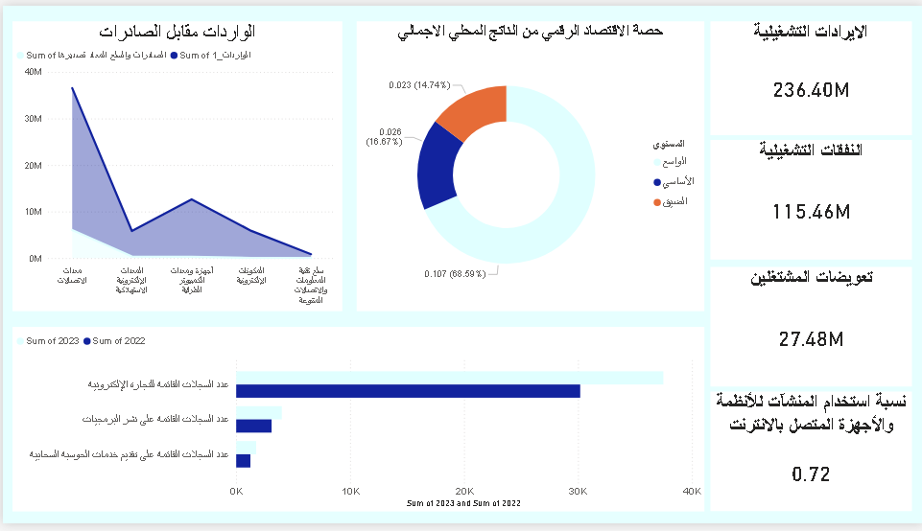

KPI
I used them to display operating revenues, operating expenses, employee compensation, as well as the percentage of facilities using internet-connected systems and devices.

Donut Chart
I used a Donut Chart to show the share of the digital economy in the gross domestic product (GDP) across the broad, basic, and narrow scopes.

Stacked Area Chart
I added a Stacked Area Chart to display imports of ICT goods versus exports.

Clustered Bar Chart
I used it to compare the number of records related to e-commerce, software publishing, and cloud computing services between 2022 and 2023.

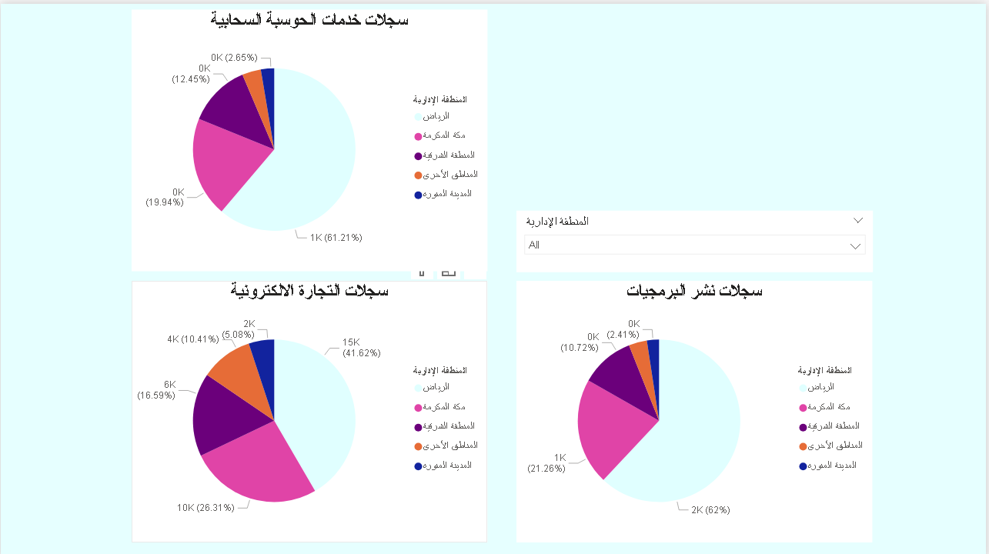

Pie Chart
I used three Pie Charts to display the number of records related to e-commerce, software publishing, and cloud computing services for each administrative region in Saudi Arabia.

Slicer
I added a Slicer to filter the data by administrative regions in Saudi Arabia.

